Astronomy

# Common Units

* Distance/Displacement: Kilometers (km) or Parsecs (Pc) and Mega Parsecs (MPc).

# Astronomical Coordinates

## Explanation

* The earth rotates around the sun. The plane of this rotation is known as the eplictic plane. The earth also rotates about its axis, and the plane perpendicular to this axis is known as the celestial plane. The elliptical plane and celestial plane are the planes of the elliptical equator and celestial equator respectively.

## Calculation

1. Declination = Latitude. The following steps therefore encompass a calculation of the right ascension.
2. Right Ascension: (M)Calculate the number of days after the 21st of March. Divide this number by 365.25, then multiply by 24 (representing the proportion of the 24 hours rotated in a year).
3. (N) Calculate the number of hours before midnight on the day. Subtract this from 12.
4. Add the results of steps 2 and 3:

**REMEMBER:** The astronomical coordinates of the sun depend **only on the movement of the earth** in its galactic orbit, not on its rotation about its axis.

# Luminosity and Flux

## Luminosity [W or Js­­-1]

* Luminosity refers to the total amount of energy emitted by an object per unit of time (seconds).
* Light is assumed to be emitted isotropically, ie, in equal amounts in all directions.
* From Earth, we only receive a portion of the emitted light.
* Luminosity is *not* distant dependent. It should theoretically be calculated by taking. The integral of energy emitted by an object over its entire surface.

## Flux [Wm-2 or Js-1m-2]

* Flux refers to the amount of energy received by an observer per unit time per unit area.
* The equation is given as:  
    
  distance between the light source and observer.
* Distance dependent: We see that because of the inverse square rule (we have d^2 on the denominator), the flux of an object is distant dependent. If, for example, the distance between the light source (star) and the observer increases by 2, then the flux will decrease by a factor of 4 (2^2 == 4).
* **NOTE:** For the calculation of flux for the magnitudes system, we use parsecs instead of meters for measuring distance.

### Flux Scale [Janskys or mags]

**Janskys**

* Flux can be expressed in terms of SI units: Janskys, which are equivalent to:  
    
  Note that the Janskys units are linear, so if a source has flux of 4 Janskys, it is twice as bright as a light source of 2 Janksys.
* However, because the range of flux is large (from 10 to 10^30 units), we instead use a logarithmic scale.
* Magnitudes: The alternative scale is therefore known as the magnitudes scale. It is based off a factor of 2.512.

**Magnitudes [mags]**

* The magnitude of brightness for a single object is given by:  
    
  x refers to the magnitude of the object of interest, fx refers to the flux of the object of interest, and f0 refers to the flux of a defined object, ie, an object whose magnitude is defined to be 0. This object, for astronomy, is known as the Vega star.
* Comparison: To compare the brightness of two objects, we use:  
    
  0 is no longer present is because it cancels out when we combine the two magnitude equations for both objects into a single log equation. The proof is left up to the reader.
* Scale: As seen above then, due to the negative polarity of the coefficient, we see that the more negative the relative magnitude, the brighter a star will be.
* **Remember:** We use **parsecs instead of** **meters** when measuring the distance for flux in the magnitudes equation.

**Absolute Magnitude**

* Up to this point, we have been evaluating apparent magnitudes (m), which is associated with flux.
* On the other hand, if we wish to calculate the absolute magnitude of brightness (M), which is associated with Luminosity, we use the same relative magnitude equation as specified above.
* Using the relative magnitude equation, we set ma to be the apparent magnitude (m) of the object of interest, while mb is the absolute magnitude (M) of the object. Thus we have:  
    
  becaue we know that fm and fM will have the same luminosity, we can cancel all the constants (L, 4, pi) to get:
* Adjusted for MegaParsecs:

## Astronomical Distances

* Instead of using meters, which often leads to large measurements, we use parsecs. The number of parsecs is defined by:  
    
  the distance in parsecs, and p represents the parallax angle, **with units of arcseconds**. The parallax angle is labelled below:

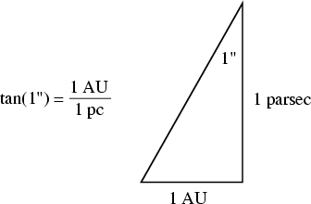In other words, the a parsec is defined as the side adjacent to the angle subtended by 1AU.

## Standard Candles and Distance

* As covered previously, we can relate the absolute and apparent magnitudes through the equation:
* This means that if we can know both m and M, then we can determine the distance of an object (e.g, galaxy or start) away from us.
* We CAN determine both m and M of an astronomical object through Cepheid stars.
* Cepheid stars are stars which pulsate, with the pulsation period dependent on luminosity.
* Therefore, if we can find the pulsation period of a star, we can find the luminosity (M), measure the apparent magnitude (as per a normal measurement) and therefore find the distance.
* We use the following equation to find the absolute magnitude:  
    
  and Mv represents the absolute magnitude of the star.
* Therefore, substituting this into our previous equations for the absolute magnitude , we have:  
    
  Note that the above equation gives the distance in Parsecs.

# Stellar Nucleosynthesis

## Source of Solar Radiation

* Nucleosynthesis via nuclear fusion.
* E = mc2.
* This is the only viable method of Luminosity, as the other methods, gravitational and chemical, would indicate that the sun is only millions or thousands of years old.

## Nuclear Fusion

* Requires high temperatures and pressure to overcome coulombic repulsion forces between protons (Coloumb barrier).
* In turn, the temperature of an object is dependent on its mass:  
    
  Note: There are more lines of working out required for this formula to be derived, but will not be covered in these notes.
* Therefore, we can determine the temperature of the sun:

## Reaction Chains

* PP chain
* CNO (Carbon-Nitrogen-Oxygen)
* Triple Alpha

### PP Chain

* Hydrogen atoms collide and undergo nucleosynthesis.

### CNO Chain

* Carbon is required as a catalyst to produce more Carbon and Helium.

### Triple Alpha

* 2 Helium atoms undergo fusion reactions to produce beryllium. Beryllium in turn undergoes fusion with another helium to be converted into carbon. Carbo then undergoes fusion with Helium to produce Oxygen.
* Instability Bottleneck: The problem with the Triple Alpha process is that there is a bottleneck of unstable atoms produced from atomic number 5-8.

## Relative Occurrences of Reaction Chains

* As the temperature increases, the probability of each reacation chain occurring, ranked from lowest to highest, is PP, CNO, and Triple Alpha.
* This means that at high temperatures, and therefore with objects of great mass, the Triple Alpha process will tend to dominate, followed by the CNO chain and finally, the PP chain.

## Black body spectrum

* Hotter star spectra peak at more blue wavelengths.
* Colder star spectra peak at more red wavelengths.
* Overall, based on the integral under the curve, the energy emitted by hotter star spectra is greater than that of colder stars.

### Deriving the Temperature of the Sun

* From Wien’s Law:  
    
  Note: In the above evaluation, we obtained 500 x 10^-9 by observing the maximum wavelength of light emitted by the sun. ‘
* Therefore, given that we had previously determined the core temperature of the sun to be a much greater temperature, it has been deduced that nucleo synthesis only occurs in the solar core.

## Kirchhoff’s laws

* A hot opaque body will emit light in a continuous spectrum.
* A hot, dense gas will emit an emission line spectrum, with a series of bright spectral lines superimposed on a weaker continuous spectrum.
* A cold, dense gas in front of a light source emitting a continuous spectrum will absorb light of specific wavelengths, producing an absorption spectrum with dark spectral lines superimposed on the continuous spectrum.

## Harvard Spectral Sequence

* Describes the spectral classes of light and the celestial bodies which produced them.
* The acronym is given by: OBAFGKMRNS, or:  
    
  *Oh Be A Fine Girl, Kiss Me Right Now Sweetie.*
* Note: R, N and S classes are no longer used, except to make the mnemonic more memorable.

# Properties of Stars

## Doppler Shift

* The wavelength of a wave emitted by a source, and that received by an observer, differ by an amount that depends oupon the relative motion of source and observer.
* Occurs due to the motion of wave sources compared to observers.
* If the source is moving towards the observer, the observer will observe that the wavelength is compressed (blue shift for light).
* If the source is moving away from the observer, the observer will observe that the wavelength is elongated (red shift for light).
* **Note:** the Doppler shift cannot exceed the speed of light.

## Hertzsprung-Russel Diagram

* Color is the log of the ratio of the fluxes.
* Essentially, the Hertzsprung Russel diagrams describe a relationship whereby colour corresponds to absolute magnitudes.
* B-V is the absolute magnitude measured through blue filter, and absolute magnitude measured through V filter. This tells us the ratio of the two fluxes.
* People would neasure fluxes, which gives luminosity, then measure fluxes through two different wavelengths – so using two different filters. Plot the colour, which is the log of the ratio of the fluxes.

### Three Key Features

* Main Sequence.
* Giants
* Dwarfs
* Each of these key regions represent some relationship between colour and absolute magnitude.

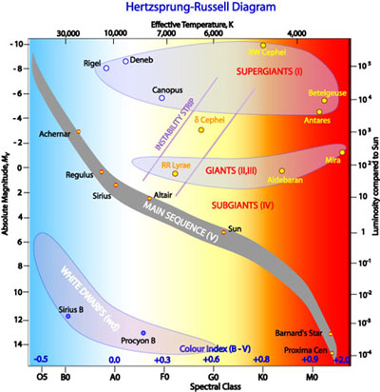

* The diagram above illustrates the main regions (disregarding the supergiants). What the diagram does is allow us to describe a relationship between mass, absolute magnitudes (luminosity) and colour (described as spectral class in the diagram, x axis), which in turn correlated to surface temperature due to Wien’s Law.

## Binary Systems

* Two stars in mutual gravitational attraction, orbiting a common center of mass.
* The study of Binary Systems allowed the following:
  + Establishing the Luminosity and Mass relationship.
  + Explaining the Main Sequence in terms of mass delineation
  + Calibrating stellar Main Sequence lifetimes.
* There are two main types of binary systems:
  + Visual: This simply refers to two stars seen moving together, but not necessarily orbiting a common center of gravity.
  + Close Binaries: Not separtated as two binaries in the star (too close). This in turn includes two other binary types:
    - Spectroscopic binaries: 2 stars with Doppler shifts in opposite directions, varying as they orbit the common center of mass.
    - Eclipsing binaries: Regular eclipses of one start by its companion, and vice versa half an orbit later.

Main Sequence Lifetimes

* The main sequence life time simply refers to the average lifetime for stars found on the main sequence as given by the Hertzsprung Russel Diagram.

# Initial Mass Function

* Here, F(N) represents the represents the proportion of **number of** stars with mass between “a” and “b”.
* F(M) represents the proportion of the **total mass** of stars comprised by stars of mass x up to 20.

## The Stellar Lifecycle

* Star Formation:
  + Molecular Clouds
  + Star Clusters.
* Initial Mass Function
* Stellar Endpoints:
  + Stellar Nebular:
    - Average start -> Red Giant -> Planetary Nebula -> White Dwarf
    - Massive Star-> Red Supergiant -> Supernova:
      * Neutron Star
      * Black hole

# Galaxies

## Working Model (Features – Inside to Out)

In order, from inner to outer galaxy

* Nucleus
* Bulge
* HI gas disk
* Stellar Disk
* Globular clusters
* Dark Matter Halo
* Companion

## Components of a Galaxy

* Dark Matter (90%)
* Stars (9%)
* Gas Disc (0.9%).

## Galaxy Types

* Ellipticals
  + Older galaxies.
  + Soft egg shape.
  + Smooth Profile.
  + Often yellow or red in colour. (Offically red, but often they will appear yellow).
  + Luminosity: High.
  + Absorption lines only.
  + No Dust Lanes.
  + No rotation.
  + Star formation rarely (if ever) occurs.
  + Absolute magnitude between -22 to -18.
* Spirals:
  + Middle Aged
  + Red/Yellow bulge, but bluish arms and disc.
  + Dusty.
  + Spiral Shape.
  + Luminosity: Moderate.
  + Absorption and emission lines.
  + Disc rotates.
  + Star formation still ongoing (primarily in dust lanes in spirals).
  + Absolute magnitude between -21 to -17.
* Irregulars:
  + Young galaxies.
  + Blue.
  + Very Dusty.
  + Asymmetrical.
  + Luminosity: Low.
  + Strong emission lines.
  + Rotation.
  + Star formation occurs constantly, and has the highest rate of all galaxies.
  + Absolute magnitude between -18 to -10.
* Others:
  + Dwarves.
  + Crouching Giants.

## Explanation of Luminosity and Colour

**Colour**

* Galaxies will emit light of all stars.
* However, the colour of the stars which dominate in the galaxy will also dominate. That is, the spectrum of a galaxy is equal to the sum of stellar spectra, so if the majority of stars are blue, then blue will dominate as the colour.
* Hence, while all galaxies will emit light of different wavelengths, the colour of the most common star type will dominate. Thus, in elliptical galaxies, since the majority of stars are old, red stars dominate and so the elliptic galaxies appear red.

**Luminosity**

* Regarding Luminosity, or the brightness of a galaxy then, the natural question is why the irregular galaxies are less bright than the elliptical galaxies even though they emit light of of greater frequency and energy.
* The reason is because Luminosity is related to mass, and because elliptics have greater mass, they will also tend to have greater brightness.

## The Hubble tuning Fork

* Objects classified from Early to late:
  + Ellipticals are early, spirals are late.
  + Lateness is given by the bulge-disk ratio and the tightness of the spiral arms.
* Not an evolutionary sequence.
  + Isolated systems will not spontaneously start to rotate.
* Spirals subdivided according to whether they exhibit a bar or not.
* Flaws: The discovery of the dwarf stars makes the Hubble tuning Fork impractical. As such, we are now implementing a new system.

**New System**

* The new system recognizes three types or two primary components:
  + Types: Ellipticals, Spirals, Irregulars.
  + Components: Spheroids (dynamically hot) and discs (dynamically cool):
    - Discs may also contain a bar.
    - The spheroid may contain a nucleus.

## Calculations of Star Numbers, Density and Light-to Mass Ratio

### Star Numbers

* Let there be a standard star, called A, with an apparent magnitude of f*. We then assume that the galaxy is comprised of n* number of similar stars, also with magnitude f*.
* This tells us that if we find the difference in the magnitude of brightness of the galaxy (whose light will come in a majority from stars like A), we have:

### Star Density

* Recall the equation for Absolute Magnitude (in MegaParsecs) is given by:
* Therefore, we can find the distance to a galaxy of certain brightness, called B, through the equation:
* As such, we can calculate the volume of an imaginary sphere which contains galaxies like B:
* Given a known number (N) of those galaxies in the sky, we calculate the density of those galaxies in space through the equation:

### Mass to Light Ratio

Here, M/L represents the mass to light ratio of some galaxy, let’s call it A, while X represents how large the mass to light ratio of A is compared to the mass to light ratio for our own Galaxy. The natural implication of this is that Mx/Lx represents the ratio of solar mass to solar luminosity.

### Denisty of the Universe

* Given the space density of a certain type of galaxy and the mass of each of those galaxies, we can estimate the density of the universe by assuming that the universe is made up of those galaxies (so this is really just an approximation). This is given by:

# Galaxy Spectra

## The 4000 Angstrom Break

### Background

* Angstroms are another unit of measurement for length, and is equal to meters.

### Theory

* As mentioned previously, all galaxies will emit light of all frequencies/wavelengths to some degree. However, eventually the frequency of light emitted from the majority star type will dominate the spectra, since the spectra is just the sum of light emitted by the stars.
* As such, we tend to observe in stars a break in a galaxy’s spectra at 4000 angstroms and below(Reason unknown currently).
* To clarify, this break simply implies a sudden drop in the intensity (or flux according to other sources) for wavelengths less than 4000 angstroms (light of greater energy, ie, towards the blue end of the spectrum).
* This usually corresponds to the fact there are many sources of light which emit light towards the red end of the spectrum, while there are relatively few sources towards the blue end of the spectrum.
* The 4000 Angstrom break is illustrated here:   
    
    
    
  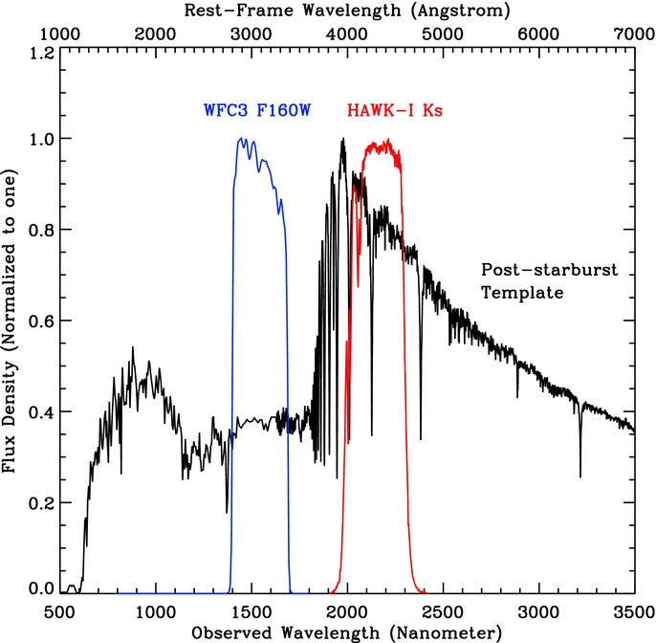**Note:** The reasons for what appears to be a secondary break at 800 Angstroms is unknown, we’ll ignore it for now.

### Cause

There are two main causes of the Angstrom break.

1. The blanket absorption of high energy light by metals in the stellar atmosphere.
2. The lack of blue stars in the galaxy.

### Implication

* The effects of the causes listed above is that ellipticals, which have no star formation and has an abudnace of high mass metals, will have a very “strong” (sharp change in the intensity) angstrom break.
* Spirals on the other hand have a weak 4000 angstrom break.
* Irregulars have no 4000 Angstrom break.

## Absorption and Emission Lines

### Causes

**Causes of Absorption**

* Absorption lines can be caused by the atoms or moleculesin a star’s atmosphere (following the same principle of absorption spectra for elements).
* Absorptions lines can also be caused by **COLD** gas clouds in the interstellar medium, which can **EXTRACT** energy from the passing radiation.

**Causes of Emission**

* Ionised gas is heated then re-radiate light of specific frequencies corresponding to the energy of allowed transitions by the electrons.

### Requirements

**Absorption**

* Metals in the stellar atmosphere
* Cold gas in interstellar medium.

**Emission**

* Very hot gas and O and B type stars.

### Implications

**Absorption Lines**

* Elliptic type galaxies, or spiral galaxies with bulges.
* Old, little star forming processes occurring.

**Emission Lines**

* Spirals or irregulars.
* Newly formed stars, many star forming processes occurring.

## Red Shift

### Background

* It has been observed that the majority of galaxy spectra have been redshifted.
* This implies that the galaxies are moving away from the Earth.
* The way that the redshift was detected was by comparing the wavelengths of characteristic emission lines in the lab to those observed from stars.
* As such, it was found that the wavelengths from stars was greater than that measured in the lab.
* This redshift was originally interpreted as a form of Doppler Shift, described by:  
    
  lambda represents the reference wavelength, Delta lambda refers to the difference between the observed and reference wavelength, v represents the velocity of the galaxy, and c is just the speed of light.   
  **Note:** Here, the second equation (to the right of the arrow) was formed by expanding the first equation as:

### Theory

* The universe is in fact expanding, so **space time is stretching**.
* As such, the redshift isn’t the same as Doppler Shift, but is **caused by the stretching of time and space**, which makes it appear as if the object is moving away.
* The implication of this is that the object **isn’t actually moving away**, because its position in the universe relative to that of the earth’s is still the same, but because space time stretches, the wavelength is also stretched.
* Therefore, **redshift isn’t the same as Doppler Shift**. This is because Doppler shift occurs due to the differences in reference frame, while redshift occurs due to the stretching of space and time. Redshift occurs with stationary object.

### Calculations

**Hubble Calculation**

and H0 represents the **Hubble Constant**, which has an approximate value of   
  
**AGE OF THE UNIVERSE  
  
Redshift**

coefficient, the change in lambda is the difference between the observed wavelength and the reference wavelength, and lambda0 is the reference wavelength.

* It should be noted that while we often say that   
    
  to say that:  
    
  Where V_radial is given by:  
    
  And therefore:
* Hence, while before, without knowing that z really just corresponds to radial velocity, we would’ve calculated the distance to a galaxy through the equation:  
    
  quite accurate, as it assumes z = V_recessional. Instead, we use the equation:
* This is the general equation and can be used whenever, so if we don’t need to account for the peculiar velocity (or V_infall) of a galaxy, we can just set V_infall to 0.

**Deriving Mass from Inclination and Wavelength offset**

* The basis for such a question would usually involve some line thickness, which tells us the total amount of redshift or difference in velocities between opposite ends of the galaxy. We would also usually be given the inclination, ie, the major and minor axis lengths.
* Using the major and minor axis lengths, we can calculate the angle of inclination.
* We then use the equation:  
    
  / = v/c VObserved = / * c
* However, to then calculate the rotational velocity, we account for the fact that  
    
  Vobserved = Vrotational sin(i)Vrotational =Vobserved/sin(i)
* Given the Virial theorem, we have:  
    
  GmM/r2 =mv2/r M = v2r/G
* To calculate the radius of the galaxy, we need to measure the distance to that galaxy and multiply it by tan(j), where j represents the angle subtended by the radius of the galaxy and the distance to the galaxy.
* To determine the distance, we use the Hubble equation:   
    
  d= zc/H0  
    
  Where z is calculated by the equation:  
    
  z =   
    
  Where Delta lamda in this case represents the difference between the wavelengths of some emission line measured from the galaxy and on earth.
* We can then calculate the radius of the galaxy through the equation:  
    
  **NOTE:** The angle represented here by theta **is not the angle of inclination**, rather, it is the angle subtended by the radius of the galaxy and the distance to that galaxy.
* Therefore, after calculating the radius, we can determine the Mass of the galaxy.

# Dark Matter

## Virial Theorem (Basic Y12 equation)

* Not sure how this is relevant.

## Evidence for Dark Matter

at mass distribution is relatively constant towards the edge of the galaxy

However:

But! The mass of visually observable objects (stars and gas predominantely) is centrally concentrated. Hence, to account for the increasing mass towards the edge of the galaxy, there must be some additional mass component at the edge of the galaxy. This mass is explained by **dark matter**.

In other words:

Which is the equation for an isothermal sphere and implies a spherical halo of extra mass.

**Verbal Explanation**

* We assume that the stars and gas are centrally concentrated, and that the majority of the mass of a galaxy corresponds to the location of the stars.
* As such, given the equation of the Virial Theorem, we expect that the rotational velocity of the galaxy decreases as we move to the outer edges of the galaxy. **Remember**: However, this decrease in velocity **is not due to a decrease in mass**, but rather, occurs because mass is assumed to be relatively constant on the edge of the galaxy, and because of the increase in radius, velocity decreases.
* However, what is actually observed is that the velocity of the galaxy towards the edge essentially remains constant as we move further out from the center.
* This indicates that there is some additional mass component, which means that the stars don’t trace the mass of the galaxy.

**Summary**

* Almost all spiral galaxies have flat rotation curves. Therefore, the stars don’t indicate the majority distribution of mass. The extra mass must come from some other component of galaxies – **dark matter.**

## Nature of Dark Matter

### Normal (Baryonic matter)

* Ionised gas.
* Cold dust
* Planets
* White dwarves
* Black Holes
* Masive Compact Halo Object

### Exotic (non-Baryonic matter)

* Cold: Weakly Interacting Massive Particles
* Warm: Sterile Neutrinos, Gravatinos
* Hot: Neutrinos

### Modification to Gravity

* Modified Newtonian Gravity, which adds a further aspect to General Relativity, which adds an additional force law, which only becomes significant in extreme distances or extremely low densities. Only applicable to galaxies however.
* Weyl Gravity or Conformal Gravity: Adds effect to gravity which exists in all other forces.
* Causal Set theory (discretised time) -> if time is a series of moments which changes space time, which could explain dark energy.

# Galaxy Formation

Currently, there are two main models.

## Hierarchal Merging

* Two Galaxies merge, forming a larger galaxy.

## Dust formation

* Dust accumulates in local area.

# Cosmology

## Copernican Revolution

**There is nothing special about the location of the Earth in the cosmos**

* The universe doesn’t revolve around the Earth.

## Olber’s Paradox

* We assume that the universe is infinitely large with infinite age.
* This implies that the sky is bright at all day and all year around.
* However, the sky at night is dark.

**Test Solution**

* Given an infinitely old universe with a uniform distribution of stars, we would expect every sight line from the earth will intercept the surface of a star.
* The amount of light from a certain distance does not change as we simply span a greater amount of stars at a greater distance even though the flux from each star decreases.
* As such, the night sky should be at least as bright as the sun.
* However, this is clearly contradicted by the fact that the night sky is dark.
* This is resolved by the idea that even if the universe is expanding, if it has a finite age, then we can only receive light from a finite portion (since it takes light time to travel).
* If the universe were homogenous, isotropic, infinite in age and unchanging, then every sight line from the earth would intercept the surface of a star. The decreasing flux from stars at a greater distance would be counteracted by the fact that we intercept more stars at a greater distance.
* As such, it would be expected that every part of the sky would be infinitely bright.
* However, this is clearly not the case.
* Therefore, the solution is that the universe is of a finite age, even though it may be infinite, and because light takes time to travel, we only receive a finite portion of light.

### Potential Solutions

* Intervening Dust: Intervening dust could absorb the radiation from distant stars. However, the dust itself would also heat up and radiate as brightly as a star.
* Finite Age to the stars and Universe:

The FULL DIAMETER OF A GALAXY CAN ALWAYS BE FOUND

The width of the long slit lines spectrum for a galaxy tells you the difference in velocity/wavelengths between light emitted from stars at one end of the galaxy, and stars at the opposite end of the galaxy.

Quantum Physics

**Schrodinger Equations**

# Wave Nature of Matter

## Particle in a box (Potential Well)

Is the Bohr model accurate?

## Schrödinger Equation

**Solving for Energy**

***Which AGREES with the Bohr model***

# Quantum Numbers

* **n:** The principle quantum number. Note, the current belief is that this does not necessarily correspond to the “ring” of the electron’s orbit.
* **l:** Orbital Angular Momentum number.
* **m­l:** The Orbital Magnetic Quantum momentum number.
* **s:** The Spin quantum number.
* **ms:** Spin magnetic quantum number.
* **L:** The orbital angular momentum of an electron.
* **S:** Spin angular momentum.
* **J:** The total angular momentum.
* **j:** Quantum number of unknown name.

## Properties

* **n:** The principle quantum number. This can take values from:   
    
  So the number of n values is **infinite**.   
  Also note that this n is the same variable as that used in the Bohr model.
* **l:** The orbital quantum number. The values of l are dependent on the values of n, given by:  
    
  **n** value, the total number of l values which can occur is **n**.
* **ml:** The orbital magnetic quantum number. The values of **ml** are dependent on l, and are given by:  
    
  the total number of ml values possible for a given n value is:  
   full proof of this, we use the rule for an arithmetic series.)
* **s:** Spin quantum number. This can only take the value of 0.5.
* **ms:** The spin magnetic quantum number. This can take values of .
* **L:** Orbital Angular momentum. The magnitude of L is given by:  
    
  The z component of l on the other hand, is given by the equation:
* **S:** Spin angular momentum. The **magnitude** of spin angular momentum is given by:  
    
  **z component** of spin angular momentum on the other hand is given by:
* **J:** Total angular momentum.

## Probability

* This equation indicates that the square of the wavefunction is the probability density.
* As such, we may write:

## Number of Electrons for each Orbital Quantum Number

By the Pauli Exclusion principle, the number of electrons which can be in the state described by l, the orbital angular momentum number, is given by:  
  
  
number of possible ml values is 2l+1, but furthermore, because Pauli’s Exclusion Principle states that no two electrons can have the same set of quantum numbers (n, l, ml, s, ms), for each ml, there can only be two ms values (0.5 and -0.5).

# Radial Probability Densities

is given by the wavefunction. However, in this version, they’ve switched in terms of what you would normally see in units such as MATH1011. The MATH1011 version of this equation would be:  
  
**Graphs of Radial Probability Densities**

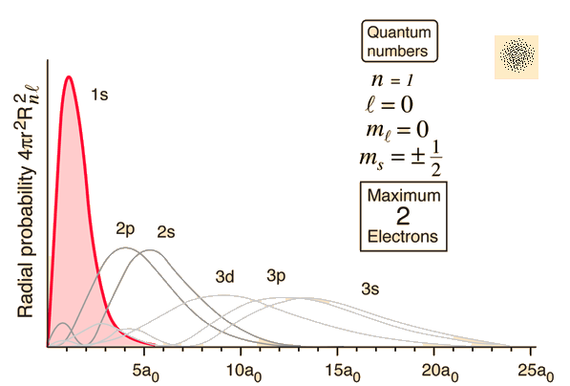

* The number of anti-nodes (maximums) for each graph is given by .
* What this tells us is that, as explained below (in the section called “[Binding Energy](#Binding Energy)”), for a given term symbol , representing the quantum state of the outer electron, the screening charge approaches perfection (ie, becomes larger) as .
* This is because as we increase *n*, our graph of the RPD moves further out from the radial probability densities of the inner electrons, which means we are less likely to be found in the Gaussian sphere containing the inner electrons.
* We also approach perfect screening for a given *n* value as . From the graph, this is represented by the fact that as *l* increases, the number of antinodes decreases, which again decreases the probability that the outer electron is found within the Gaussian sphere containing the inner electrons.

# Binding Energy

Binding energy refers to the total energy required to disassemble a nucleus into its components. Binding energy increases as energy is released when a nucleus is formed. When nucleons form a nucleus, they lose a small amount of mass. This mass loss must be released as particle energy, such as EM radiation, gamma radiation, or the kinetic energy of an ejected particle.

To get the screening charge to as near perfect as possible, we require that we have the maximum orbital quantum number for a given principle quantum number.

This is because by the Radial Probability Density function, as we increase the principle quantum number, the probability distribution for the outermost electron goes out further and further from the probability distributions of the inner electrons. This means that there is a decreasing likelihood that the electron will be found inside a gaussian sphere also containing the inner electrons. This means that the net charge exerting a force on the outermost electron will become a better approximation of . Hence, we approach perfect screening as our principle quantum number increases. However, the number of peaks associated with the principle quantum number also increases, and for low orbital numbers, this actually puts the outermost electron at a greater probability of being inside the Gaussian sphere containing the inner electrons, and therefore reduces the probability of perfect screening. Therefore, since the number of peaks is given by , we can approach perfect screening as our orbital number increases.

# Term Symbols vs Electron Configurations

For multi-electron atoms

* For Electron configurations, this means that we write out all the electrons in their respective shells, accounting for the principal quantum number and orbital angular momentum number. For example, for a singly ionised Magnesium ion, we might use:

# Effective Nuclear Charge

eff is the effective nuclear charge, and sl is known as the l dependent screening charge, which is really just the number of electrons between the nucleus and the outer electrons as the orbital angular number increases. From empirical evidence given by Frank, it seems that imperfect screening means the screening charge is less than what it should be.

* The reason that the screening charge is said to be l dependent is because the screening charge is maximised (or rather, takes it’s “proper” value) when l is maximised for a given principal quantum number.
* In other words, we can break down the effective nuclear charge into two rules:  
    
  Note that here, represents the number of electrons between the outer electron and nucleus.

Resonance

**Stability**

* A system is said to be stable if there is a force acting on the system in the opposite direction to its displacement.
* Alternatively, a system is said to be stable if there is a point at which its potential energy is a minimum.

Mechanical Resonance

# Simple harmonic motion

Here, *k* represents some constant which is *material dependent*. *x* simply refers to the displacement of the object in question. The negative sign for the first equation simply indicates that the force is trying to return the object in question to the origin.

* Also note that in both solutions for the equations of x, the parameters which depend on **initial conditions** are *R, ,* ***A*** *andB*.
* Also note that the equation was derived from the equation via the trigonometric identity: , and we can therefore infer that and . Therefore:
* The above derivation in fact supports the fact that the parameter *A* is **dependent** on initial conditions, contrary to previous beliefs.

**Similarity with Pendulum equation**

Therefore, given that:

This implies that

* Therefore, we see that the resonant frequency as described by a mass on a spring is analogous to that, as we shall see, for a simple pendulum.
* However, the diligent reader would’ve recognised the omission of a negative sign from the equation, which is currently unaccounted for from Prof.Van Kann’s explanations.
* Likewise note that x is the displacement of the mass from the origin, not the length of the spring.

# Pendulums

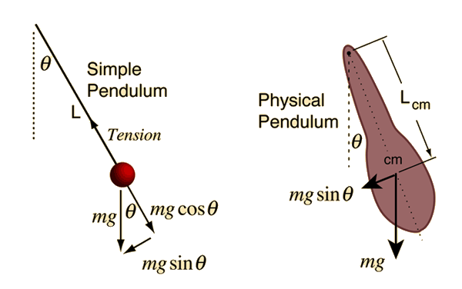

## Linear Motion Interpretation

Therefore

## Angular motion interpretation

So, because at small angles is approximately equal to , we have:

# Potential Energy

## Derivation

From Hooke’s Law, we know that:

Therefore:

**Note**: In this case, although it seems that we have forgotten the negative, the current belief is simply that the negative is only used to indicate that the work is in the opposite direction to motion, but because **energy** is a scalar, we can omit the negative sign.

### Spring

### Pendulum

**Kinetic Energy – Total Energy**

Recall that an object’s kinetic energy is given by:  
  
, and , we can derive the equation:

# Frequency – Torque

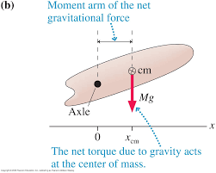

Therefore, given the small angle approximation, which states that for small angles: , we may say that:  
  
rotation will tend to be clockwise for most systems, since a clockwise direction is set as negative. In other words, because the torque tends to move the system back to equilibrium, the torque vector is **manually set as negative**(by ourselves).

* The real working however, falls on the idea that is described by some function, so we may imagine:
* And therefore we solve for:
* Formally, the solution is given as:  
    
   is the distance between the pivot point and center of mass, and is the radius of gyration.
* **Note:** Although the mathematics are a little unclear at this point, it is stated that as the angle approaches 180 degrees, the period of the oscillator tends towards infinity.

## Torsional Oscillator

Note that this was derived from:

(by Hooke’s law in angular form), and therefore:

# Friction in Simple Harmonic Motion

**An interesting visualisation (kinetic friction)**

* Kinetic friction is proportional to velocity, and therefore, we can essentially plot a graph of kinetic friction vs velocity, where friction is a positive quantity when velocity is negative, and vice versa.
* Visualising friction vs displacement is impossible.

## Damping

* As noted above, the frictional force exerted on a system undergoing simple harmonic motion is often represented as a damper dashpot (at least for a spring system it seems).
* 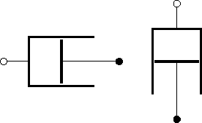The dashpot is often denoted on graphs as:

## Solution for Damped Oscillatory motion

We can solve the system of equations by just “guessing”, and we derive the equation:  
  
  
  
Or:

Here, the variables R and are dependent on initial conditions, while and are natural parameters, which depend on the variables of m, k and b. Also note that we used to indicate that the phi value used in the second equation **will not** have the same value in the previous equation (because as you’d expect, if we have the same initial conditions and displacement, we need a different value).

* The solutions for finding and are given by:  
    
  Where *k* represents the spring constant, m represents the mass of the spring, b represents the constant for the frictional force, and is just some time constant.
* Analysing the solution for the omega value heuristically, we see that it will always be lower than .
* We can therefore find the solution for the resonant frequency as:
* Note that in the above calculation, we used the equation
* Also note that while it may seem confusing, and are not the same variable.

### Noteworthy Cases

* Case 1: If b = 0, then we just have simple harmonic motion
* Case 2: If b > 0, we have damped harmonic motion
* Case 3: If b < 0, we have an impossibility.

## Quality Factor

The quality factor is simply defined by the equation

* It is noted by Prof. Kann that from the above equation, the component is the energy storage, while *b* is the loss of energy. At this point, the reason is currently unknown.
* Given this equation then, we can say that there will only be real solutions to the damped motion equations if the quality is greater than or equal to half. When Q = 0.5, we have what’s known as “critical damping”. This is because if .
* Given an equation for displacement as:
* From the above equation, we can see why the total energy of the pendulum would be decaying in steps: when the time constant, , is large, the sin part of the equation becomes negligibly small, so the decrease in energy is essentially described by the cos function, which is 90 degrees out of phase with the displacement.
* What follows is what Professor Van Kann calls transient solutions, which depend on the parameters *R* and , or the initial conditions.

# Maximising the Response for Forced Oscillation

* To see the derivation of this, we refer to Wolfson 3rd edition, Volume 1, page 253, which describes the amplitude for the response to a given force as:  
    
     
    
  We then differentiate this equation and solve for zero (just a standard optimisation procedure), and solutions will yield either zero or the solution given above. The proof is left up to the reader.

Electrical Resonance

Essential Formulae

# Mechanical

# Electrical

Essential Concepts

# Mechanical

* Critical damping:

# Electrical

* Kinetic energy equivalent: Inductance, since kinetic energy is associated with mass.

# Graphs

## Mechanical

* Peak: As far as we can tell, the peak of the amplitude graph for mechanical oscillators (springs at the moment) is simply given by the value of Q.
* Resonance frequency: As far as we can tell, the resonance frequency of a system is simply the amount by which the spring is stretched at equilibrium.

## Electrical

* The peak of a graph of current for an LCR system is given by (at resonance):  
    
  + A common branch of this is that we will be required to find the resistance. This can be done through the formulae:
  + Alternatively, you may have to use:

**Common Graphs**

**Voltage vs Current**

For current, simply use the equation:

ge, use the impedance formulas:

Transient solutions For the velocity equations.

The transient solutions must happen at the resonant frequency.

Transient solutions depend on initial conditions. The transient solutions always happen at the resonant frequency.

The next few solutions are:

Another class of solutions:

Forced oscillation

Get this thing moving not at its resonant frequency. See what its response is to the force.

If your’e applying a very small force, ie moving very slowly, there’s no kinetic energy, so all that matters is the potential energy. All you’re doing is moving the spring.

After the transients, it’s response force.

When we’re

The force ig onna be

The frequency with which you apply the force I much less than .

X = F/k

Applied force is way higher than resonant frequency:

What if I want to apply a force that’s way higher frequency than the resonance:

Region 2 is when we apply a tiny force, and is at the frequency of the resonance frequency. We end up in a steady state. The work that we’re putting in stores energy in the motion, and then when the amplitude of the oscillation gets big enough, the loss through the damping is exactly equal ot the work put in.

Equation for a forced oscillation is

Steady solution:  
  
Where the same force is applied over and over again and settles into its steady state solution. Takes time to reach steady state as with resonancy.

The solution is . This frequency here now is not the resonant freuqneyc, it’’s any value, it’s the frequency of the force applied.

What you wanna do is find the motion of this thing here as a function of the applied force.

In fat, because it’s steady state, all we need to solve is for R and phi in terms of F_0 and omega.

This is:

When we plot a graph of velocity, displacement and energy, we see that the energy loss is in steps, which is because the energy loss due to damping can only occur when there is velocity, which corresponds to the peaks in the velocity graphs, while no energy is lost when displacement is a maximum (no velocity).

Referring to Question 4 of Resonance Ass 2, we’re relatively confident after watching Lecture 5, towards the end as Frank shows the plot of frequencies vs Amplitudes, that amplitude (which is what we assume to be the quantity we’re maximising for “forced response”) is maximised when f = f0 or the angular velocity is equal to the resonant frequency. No, the actual derivation is given above, and shows that while the driving frequency is close to the resonant frequency, we have to account for a factor of .

Q only changes the peak.

All other cases are just constant.

Special Relativity

# Lorentz Factor

# Time Dilation

Here, represents the time between two events as measured by an inertial observer who sees the two events occur at the same point in space. is the time between the two events as measured by someone who is moving with a speed relative to the first observer.

# Length Contraction